Image | 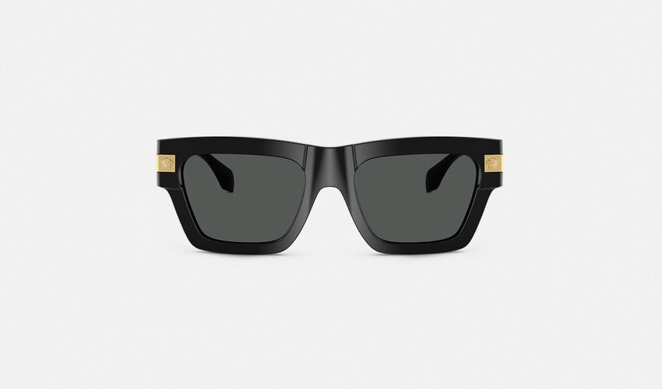
Brand | TOM FORD
Model Name | CLASSIC TOP SUNGLASSES
Price | RS 143,400
PRODUCT DETAILS

